FoxEats

Human Cyborgs

Sydonya Miller & Andrej Opancic

**Introduction:**  
  
Project Name: FoxEats

Project Purpose: Creating a database & platform for students to order food from the different options on-campus and get it delivered, similar to the 'MobileOrder' app that we already have on-campus. This is also similar to how UberEats or Grubhub operates. The platform will have a login & password checked by FoxID to make sure it is the correct user. We will also have the user's building to know where the food will be delivered, as well as contact numbers for any troubles with the orders. Each dining service will have different food options with their own prices, descriptions, and ratings. We will have a status if the dining service is open, as well as updates whether or not the food is ready, delivered, or in the process of being made. After the user picks out their order, they will have to pay with their payment of their choice (foxID, or credit card) and then the database will process the math associated with the balance and cost. This will give the user an order ID and receipt. If the user wishes to reorder the same meal, they can simply visit their order history and order again.

Target User: Students will be using our platform, as well as dining services to communicate with the students for any problems with the orders. We want our platform to be descriptive for the user and streamline the delivery process.

Data to be used: FoxID, Credit_Card, Balance, Username, Password, Contact_Number, Building, Dining_Service, Food_Category, Food_Option, Price, Food_Description, Rating, Status, Update, Order_ID, Order_History

Data Sensitivity: We will not use any FoxIDs or Credit_Card numbers used by anyone, they will be randomly generated.

Data Collection: We will gather the data from current dining service options, as well as statistics, and sort of base our app from the 'MobileOrder' framework.

Output Design: We have a login page, a home page, 5 different pages for the different restaurant screens, a confirmation page, a payment method page, and an order received page.

**Methods:**

During our design process, we decided to create what our web page would look like through digital sketches. The first two pictures made by Sydonya display the homepage that includes the login, and the other page shows the selection of restaurants that the user can choose to eat from. The second two images made by Andrej show the item selection within one of the restaurants previously selected, while the other shows a confirmation screen with the items in the cart, and what payment options were available. These were sort of the wireframes we used in our HTML portion of our project, however while in the process of coding the website we made other pages similar to one below to show the menu options for the different restaurants that were available. We also created a relational schema of how our database was going to work, including the connections and primary keys. For all of the codes included, Sydonya & Andrej worked collaboratively on both the back end and the front end to achieve the final output of our website.

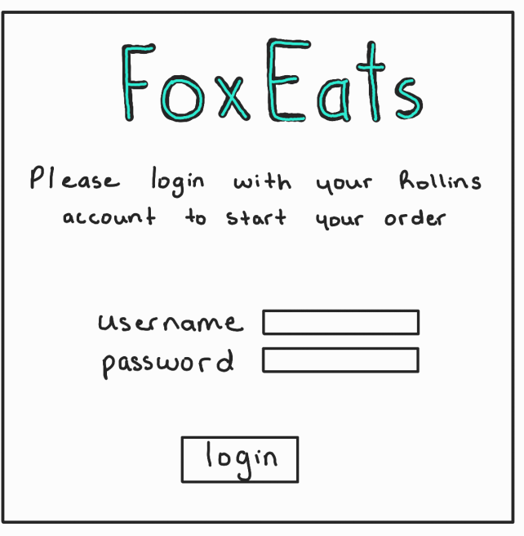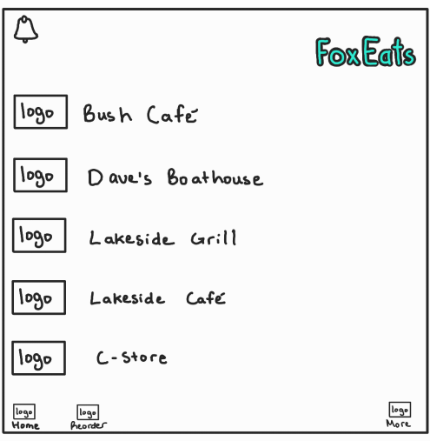

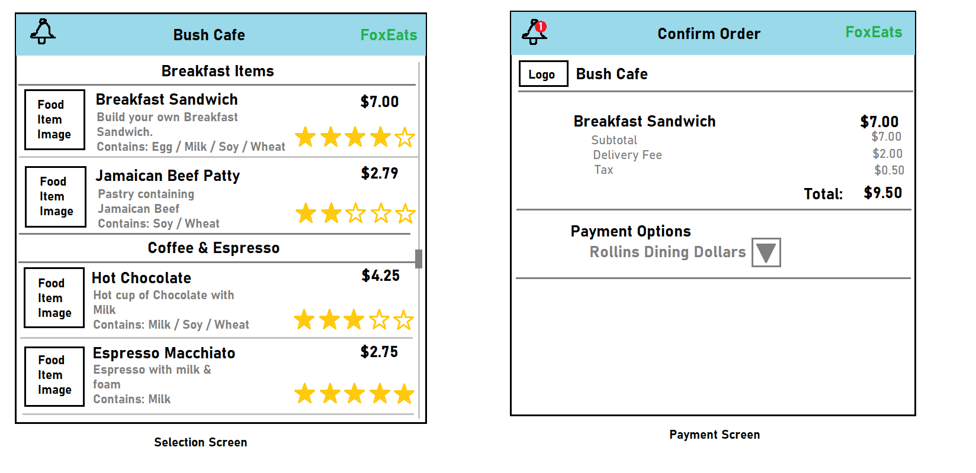

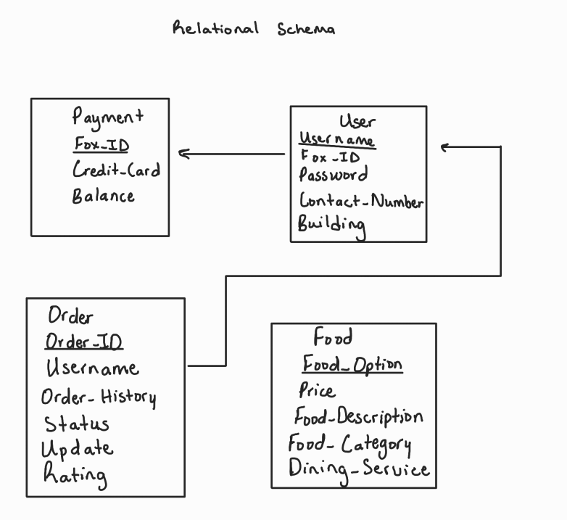

**Codes:**

For our code, we included our SQL and all of our HTML/PHP sites used throughout our website. For our SQL, we decided to cut a lot of the menus, since we wanted a small sample size to test our database first to see if everything was running correctly. The SQL was primarily made by August, but refined by Sydonya to fit our theme of Rollins dining services. For our HTML implementation, we focused on trying to keep the same aesthetic by copying the style portion from previous pages to the other ones. Every webpage has PHP implementation, meaning that our website was always connected to our database in some way, from user details, to order and food options. The HTML implementation was made by both Sydonya and Andrej.

**SQL Database:**

DROP DATABASE IF EXISTS FoxEats;

CREATE DATABASE FoxEats;

USE FoxEats;

-- Table for Food

CREATE TABLE Food (

Food_Option VARCHAR(255) NOT NULL,

Price DECIMAL(5,2) DEFAULT NULL,

Food_Description TEXT DEFAULT NULL,

Food_Category VARCHAR(255) DEFAULT NULL,

Dining_Service VARCHAR(255) DEFAULT NULL,

PRIMARY KEY (Food_Option)

);

INSERT INTO Food (Food_Option, Price, Food_Description, Food_Category, Dining_Service) VALUES

('Beef Tacos', 5.99, 'Spicy beef tacos with salsa and cheese', 'Mexican', 'Bush Cafe'),

('Butter Chicken', 10.99, 'Creamy butter chicken served with rice', 'Indian', 'Bush Cafe'),

('Cheese Pizza', 8.99, 'Classic cheese pizza with marinara sauce', 'Italian', 'Daves Boathouse'),

('Chicken Salad', 6.99, 'Grilled chicken salad with mixed greens', 'Healthy', 'Daves Boathouse'),

('Chocolate Cake', 4.99, 'Rich chocolate cake with fudge icing', 'Dessert', 'Lakeside Grill'),

('Falafel Wrap', 6.99, 'Falafel with hummus and veggies in a wrap', 'Middle Eastern', 'Lakeside Grill'),

('Pad Thai', 8.99, 'Stir-fried noodles with shrimp and peanuts', 'Thai', 'Lakeside Cafe'),

('Pulled Pork Sandwich', 7.99, 'Slow-cooked pulled pork with BBQ sauce', 'American', 'Lakeside Cafe'),

('Sushi Roll', 9.99, 'Fresh salmon sushi roll with avocado', 'Japanese', 'C-Store'),

('Veggie Burger', 7.99, 'Plant-based burger with lettuce and tomato', 'American', 'C-Store');

-- Table for Payment

CREATE TABLE Payment (

FoxID INT NOT NULL,

Credit_Card VARCHAR(19) DEFAULT NULL,

Balance DECIMAL(10,2) DEFAULT NULL,

PRIMARY KEY (FoxID)

);

INSERT INTO Payment (FoxID, Credit_Card, Balance) VALUES

(101, '1234-5678-9123-4567', 120.00),

(102, '2345-6789-0123-4568', 95.50),

(103, '3456-7890-1234-5679', 80.75),

(104, '4567-8901-2345-6780', 60.00),

(105, '5678-9012-3456-7891', 45.25),

(106, '6789-0123-4567-8902', 30.50),

(107, '7890-1234-5678-9013', 15.75),

(108, '8901-2345-6789-0124', 100.00),

(109, '9012-3456-7890-1235', 85.25),

(110, '0123-4567-8901-2346', 70.50);

-- Table for User

CREATE TABLE User (

Username VARCHAR(255) NOT NULL,

Password VARCHAR(255),

Contact_Number VARCHAR(15),

Building VARCHAR(255),

Fox_ID INT,

PRIMARY KEY (Username),

FOREIGN KEY (Fox_ID) REFERENCES Payment(FoxID)

);

INSERT INTO User (Username, Password, Contact_Number, Building, Fox_ID) VALUES

('alexl', 'hashedpass5', '407-555-0345', 'Cedar Residence', 101),

('avas', 'hashedpass10', '407-555-0234', 'Ivy Residence', 102),

('danielm', 'hashedpass7', '407-555-0789', 'Fir Residence', 103),

('emilyf', 'hashedpass6', '407-555-0567', 'Elm Residence', 104),

('janedoe', 'hashedpass2', '407-555-0456', 'Oak Residence', 105),

('johndoe', 'hashedpass1', '407-555-0123', 'Pine Residence', 106),

('mikeb', 'hashedpass3', '407-555-0789', 'Maple Residence', 107),

('oliviap', 'hashedpass8', '407-555-0987', 'Grove Residence', 108),

('sarahc', 'hashedpass4', '407-555-0124', 'Birch Residence', 109),

('williamr', 'hashedpass9', '407-555-0456', 'Holly Residence', 110);

-- Table for Orders

CREATE TABLE Orders (

Order_ID INT AUTO_INCREMENT,

Username VARCHAR(255),

Order_History VARCHAR(255),

Status VARCHAR(255),

Update_Time DATETIME,

Rating INT,

PRIMARY KEY (Order_ID),

KEY username (Username),

CONSTRAINT fk_orders_users FOREIGN KEY (Username) REFERENCES User (Username)

);

INSERT INTO Orders (Order_ID, Username, Order_History, Status, Update_Time, Rating) VALUES

(1, 'johndoe', 'Burger, Fries', 'Delivered', '2024-03-26 18:30:00', 4),

(2, 'janedoe', 'Salad, Soup', 'Preparing', '2024-03-26 18:35:00', 5),

(3, 'mikeb', 'Pizza, Soda', 'Delivered', '2024-03-26 18:40:00', 3),

(4, 'sarahc', 'Pasta, Wine', 'Cancelled', '2024-03-26 18:45:00', 2),

(5, 'alexl', 'Sushi, Tea', 'Delivered', '2024-03-26 18:50:00', 5),

(6, 'emilyf', 'Tacos, Lemonade', 'Delivered', '2024-03-26 18:55:00', 4),

(7, 'danielm', 'Steak, Beer', 'Preparing', '2024-03-26 19:00:00', 5),

(8, 'oliviap', 'Curry, Rice', 'Delivered', '2024-03-26 19:05:00', 4),

(9, 'williamr', 'Sandwich, Chips', 'Delivered', '2024-03-26 19:10:00', 3),

(10, 'avas', 'Ice Cream, Cake', 'Delivered', '2024-03-26 19:15:00', 5);

**HTML and PHP Codes:**

**Connection**

<?php

error_reporting(E_ALL);

ini_set('display_errors', 1);

$servername = "localhost";

$username = "root";

$password = "";

$dbname = "FoxEats";

$conn = mysqli_connect($servername, $username, $password, $dbname);

if (!$conn) {

die("Connection failed: " . mysqli_connect_error());

}

?>

**Login**

<?php

error_reporting(E_ALL);

ini_set('display_errors', 1);

session_start();

include 'db_connection.php';

if ($_SERVER["REQUEST_METHOD"] == "POST") {

$username = $_POST["username"];

$password = $_POST["password"];

// Fetch the user's record from the database

$query = "SELECT * FROM User WHERE Username='$username'";

$result = mysqli_query($conn, $query);

if (mysqli_num_rows($result) == 1) {

$user = mysqli_fetch_assoc($result);

// Compare the password entered by the user with the password stored in the database

if ($password == $user['Password']) {

// Passwords match, set session variable and redirect

$_SESSION["username"] = $username;

header("Location: db_home.php");

exit; // Add exit to prevent further execution

} else {

// Passwords don't match, show error

$error = "Username or password is incorrect.";

}

} else {

// User not found, show error

$error = "Username or password is incorrect.";

}

}

?>

<!DOCTYPE html>

<html lang="en">

<head>

<meta charset="UTF-8">

<meta name="viewport" content="width=device-width, initial-scale=1.0">

<title>Login</title>

<style>

body {

font-family: Arial, sans-serif;

}

.container {

text-align: center;

margin-top: 50px;

}

.login-box {

width: 500px;

padding: 60px;

border: 3px solid #ccc;

border-radius: 15px;

box-shadow: 0 0 30px rgba(0, 0, 0, 0.1);

text-align: center; /* Center align */

display: inline-block;

}

h1 {

color: turquoise;

font-size: 72px; /* 2 times bigger than previous */

margin-bottom: 20px;

}

h3 {

color: black; /* Change color to black */

font-size: 24px;

margin-top: 0; /* Remove default margin */

margin-bottom: 20px;

}

label {

font-weight: bold;

font-size: 22px;

text-align: left; /* Align left */

display: block; /* Make each label on a new line */

}

input[type="text"],

input[type="password"],

button {

width: 100%;

padding: 15px;

margin-top: 20px;

font-size: 20px;

border-radius: 8px;

border: 2px solid #ccc;

box-sizing: border-box;

}

button {

background-color: turquoise;

color: white;

cursor: pointer;

}

button:hover {

background-color: #48D1CC;

}

.error {

color: red;

font-size: 20px;

}

</style>

<script type="text/javascript">

function blockSpecialChar(e){

var k;

document.all ? k = e.keyCode : k = e.which;

return ((k > 64 && k < 91) || (k > 96 && k < 123) || k == 8 || k == 32 || (k >= 48 && k <= 57));

}

</script>

</head>

<body>

<div class="container">

<h1>FoxEats</h1>

<div class="login-box">

<h3>Please Login with your Rollins Account to Start your Order</h3>

<form action="" method="post">

<label for="username">Username:</label>

<input type="text" id="username" name="username" required onkeypress="return blockSpecialChar(event)"/><br>

<label for="password">Password:</label>

<input type="password" id="password" name="password" required onkeypress="return blockSpecialChar(event)"/><br>

<button type="submit">Login</button>

</form>

<?php if (isset($error)): ?>

<p class="error"><?= $error ?></p>

<?php endif; ?>

</div>

</div>

<script>

// Disable forward navigation until user logs in

window.onload = function() {

disableForwardNavigation();

};

function disableForwardNavigation() {

var links = document.querySelectorAll('a[onclick="window.history.forward()"]');

for (var i = 0; i < links.length; i++) {

links[i].onclick = function() {

alert("Please login to proceed.");

return false;

};

}

}

</script>

</body>

</html>

**Home**

<!DOCTYPE html>

<html lang="en">

<head>

<meta charset="UTF-8">

<meta name="viewport" content="width=device-width, initial-scale=1.0">

<title>Home | FoxEats</title>

<style>

body {

font-family: Arial, sans-serif;

margin: 0;

padding: 0;

}

.container {

max-width: 1200px;

margin: 0 auto;

padding: 20px;

}

header {

background-color: turquoise;

padding: 10px;

text-align: right;

color: white;

}

.restaurants {

margin-top: 20px;

text-align: center;

}

.restaurant {

margin-bottom: 20px;

padding: 20px;

border: 1px solid #ccc;

border-radius: 10px;

box-shadow: 0 0 10px rgba(0, 0, 0, 0.1);

}

h1 {

color: turquoise;

text-align: center;

}

.restaurant h2 {

margin-top: 0;

}

.restaurant p {

margin-bottom: 0;

}

.restaurant a {

text-decoration: none;

color: black;

}

</style>

</head>

<body>

<header>

<div class="container">

<h1>FoxEats</h1>

</div>

</header>

<div class="container">

<h1>Available Restaurants</h1>

<div class="restaurants">

<div class="restaurant">

<a href="indexFoxEats.php">

<h2>Bush Cafe</h2>

</a>

</div>

<div class="restaurant">

<a href="daves.php">

<h2>Dave's Boathouse</h2>

</a>

</div>

<div class="restaurant">

<a href="grill.php">

<h2>Lakeside Grill</h2>

</a>

</div>

<div class="restaurant">

<a href="cafe.php">

<h2>Lakeside Cafe</h2>

</a>

</div>

<div class="restaurant">

<a href="cstore.php">

<h2>C-Store</h2>

</a>

</div>

</div>

</div>

</body>

</html>

**Bush Menu**

<?php

error_reporting(E_ALL);

ini_set('display_errors', 1);

include 'db_connection.php';

$query = "SELECT Food_Option, Food_Description, Price FROM Food LIMIT 2";

$result = mysqli_query($conn, $query);

?>

<!DOCTYPE html>

<html lang="en">

<head>

<meta charset="UTF-8">

<meta name="viewport" content="width=device-width, initial-scale=1.0">

<title>Bush Cafe Menu | FoxEats</title>

<style>

body {

font-family: Arial, sans-serif;

margin: 0;

padding: 0;

}

.container {

max-width: 800px;

margin: 50px auto;

padding: 20px;

border: 1px solid #ccc;

border-radius: 10px;

box-shadow: 0 0 10px rgba(0, 0, 0, 0.1);

text-align: center;

}

header {

background-color: turquoise;

padding: 10px;

text-align: center;

color: white;

border-radius: 10px 10px 0 0;

}

.menu-item {

margin-bottom: 20px;

padding: 20px;

border: 1px solid #ccc;

border-radius: 10px;

box-shadow: 0 0 5px rgba(0, 0, 0, 0.1);

}

h2 {

margin-top: 0;

color: turquoise;

}

p {

margin-bottom: 0;

}

.back-btn {

display: inline-block;

background-color: #3cb0fd;

color: white;

padding: 10px 20px;

border: none;

border-radius: 5px;

cursor: pointer;

text-decoration: none;

margin-top: 20px;

}

.back-btn:hover {

background-color: #1e87d4;

}

</style>

</head>

<body>

<header>

<h1>Bush Cafe Menu</h1>

</header>

<div class="container">

<?php while ($row = mysqli_fetch_assoc($result)): ?>

<div class="menu-item">

<h2><?= $row['Food_Option'] ?></h2>

<p><?= $row['Food_Description'] ?></p>

<p><?= $row['Price'] ?></p>

<a href="payment.php?food=<?= urlencode($row['Food_Option']) ?>" class="btn">Order</a>

</div>

<?php endwhile; ?>

<!-- Back button -->

<a href="db_home.php" class="back-btn">Back</a>

</div>

</body>

</html>

**Daves Menu**

<?php

error_reporting(E_ALL);

ini_set('display_errors', 1);

include 'db_connection.php';

$query = "SELECT Food_Option, Food_Description, Price FROM Food LIMIT 2, 2";

$result = mysqli_query($conn, $query);

?>

<!DOCTYPE html>

<html lang="en">

<head>

<meta charset="UTF-8">

<meta name="viewport" content="width=device-width, initial-scale=1.0">

<title>Dave's Boathouse Menu | FoxEats</title>

<style>

body {

font-family: Arial, sans-serif;

margin: 0;

padding: 0;

}

.container {

max-width: 800px;

margin: 50px auto;

padding: 20px;

border: 1px solid #ccc;

border-radius: 10px;

box-shadow: 0 0 10px rgba(0, 0, 0, 0.1);

text-align: center;

}

header {

background-color: turquoise;

padding: 10px;

text-align: center;

color: white;

border-radius: 10px 10px 0 0;

}

.menu-item {

margin-bottom: 20px;

padding: 20px;

border: 1px solid #ccc;

border-radius: 10px;

box-shadow: 0 0 5px rgba(0, 0, 0, 0.1);

}

h2 {

margin-top: 0;

color: turquoise;

}

p {

margin-bottom: 0;

}

.back-btn {

display: inline-block;

background-color: #3cb0fd;

color: white;

padding: 10px 20px;

border: none;

border-radius: 5px;

cursor: pointer;

text-decoration: none;

margin-top: 20px;

}

.back-btn:hover {

background-color: #1e87d4;

}

</style>

</head>

<body>

<header>

<h1>Dave's Boathouse Menu</h1>

</header>

<div class="container">

<?php while ($row = mysqli_fetch_assoc($result)): ?>

<div class="menu-item">

<h2><?= $row['Food_Option'] ?></h2>

<p><?= $row['Food_Description'] ?></p>

<p><?= $row['Price'] ?></p>

<a href="payment.php?food=<?= urlencode($row['Food_Option']) ?>" class="btn">Order</a>

</div>

<?php endwhile; ?>

<!-- Back button -->

<a href="db_home.php" class="back-btn">Back</a>

</div>

</body>

</html>

**Lakeside Grill Menu**

<?php

error_reporting(E_ALL);

ini_set('display_errors', 1);

include 'db_connection.php';

$query = "SELECT Food_Option, Food_Description, Price FROM Food LIMIT 4, 2"; // Skip the first 4 items and select the next 2

$result = mysqli_query($conn, $query);

?>

<!DOCTYPE html>

<html lang="en">

<head>

<meta charset="UTF-8">

<meta name="viewport" content="width=device-width, initial-scale=1.0">

<title>Lakeside Grill Menu | FoxEats</title>

<style>

body {

font-family: Arial, sans-serif;

margin: 0;

padding: 0;

}

.container {

max-width: 800px;

margin: 50px auto;

padding: 20px;

border: 1px solid #ccc;

border-radius: 10px;

box-shadow: 0 0 10px rgba(0, 0, 0, 0.1);

text-align: center;

}

header {

background-color: turquoise;

padding: 10px;

text-align: center;

color: white;

border-radius: 10px 10px 0 0;

}

.menu-item {

margin-bottom: 20px;

padding: 20px;

border: 1px solid #ccc;

border-radius: 10px;

box-shadow: 0 0 5px rgba(0, 0, 0, 0.1);

}

h2 {

margin-top: 0;

color: turquoise;

}

p {

margin-bottom: 0;

}

.back-btn {

display: inline-block;

background-color: #3cb0fd;

color: white;

padding: 10px 20px;

border: none;

border-radius: 5px;

cursor: pointer;

text-decoration: none;

margin-top: 20px;

}

.back-btn:hover {

background-color: #1e87d4;

}

</style>

</head>

<body>

<header>

<h1>Lakeside Grill Menu</h1>

</header>

<div class="container">

<?php while ($row = mysqli_fetch_assoc($result)): ?>

<div class="menu-item">

<h2><?= $row['Food_Option'] ?></h2>

<p><?= $row['Food_Description'] ?></p>

<p><?= $row['Price'] ?></p>

<a href="payment.php?food=<?= urlencode($row['Food_Option']) ?>" class="btn">Order</a>

</div>

<?php endwhile; ?>

<!-- Back button -->

<a href="db_home.php" class="back-btn">Back</a>

</div>

</body>

</html>

**Lakeside Cafe Menu**

<?php

error_reporting(E_ALL);

ini_set('display_errors', 1);

include 'db_connection.php';

$query = "SELECT Food_Option, Food_Description, Price FROM Food LIMIT 6, 2"; // Skip the first 6 items and select the next 2

$result = mysqli_query($conn, $query);

?>

<!DOCTYPE html>

<html lang="en">

<head>

<meta charset="UTF-8">

<meta name="viewport" content="width=device-width, initial-scale=1.0">

<title>Lakeside Cafe Menu | FoxEats</title>

<style>

body {

font-family: Arial, sans-serif;

margin: 0;

padding: 0;

}

.container {

max-width: 800px;

margin: 50px auto;

padding: 20px;

border: 1px solid #ccc;

border-radius: 10px;

box-shadow: 0 0 10px rgba(0, 0, 0, 0.1);

text-align: center;

}

header {

background-color: turquoise;

padding: 10px;

text-align: center;

color: white;

border-radius: 10px 10px 0 0;

}

.menu-item {

margin-bottom: 20px;

padding: 20px;

border: 1px solid #ccc;

border-radius: 10px;

box-shadow: 0 0 5px rgba(0, 0, 0, 0.1);

}

h2 {

margin-top: 0;

color: turquoise;

}

p {

margin-bottom: 0;

}

.back-btn {

display: inline-block;

background-color: #3cb0fd;

color: white;

padding: 10px 20px;

border: none;

border-radius: 5px;

cursor: pointer;

text-decoration: none;

margin-top: 20px;

}

.back-btn:hover {

background-color: #1e87d4;

}

</style>

</head>

<body>

<header>

<h1>Lakeside Cafe Menu</h1>

</header>

<div class="container">

<?php while ($row = mysqli_fetch_assoc($result)): ?>

<div class="menu-item">

<h2><?= $row['Food_Option'] ?></h2>

<p><?= $row['Food_Description'] ?></p>

<p><?= $row['Price'] ?></p>

<a href="payment.php?food=<?= urlencode($row['Food_Option']) ?>" class="btn">Order</a>

</div>

<?php endwhile; ?>

<!-- Back button -->

<a href="db_home.php" class="back-btn">Back</a>

</div>

</body>

</html>

**CStore Menu**

<?php

error_reporting(E_ALL);

ini_set('display_errors', 1);

include 'db_connection.php';

$query = "SELECT Food_Option, Food_Description, Price FROM Food LIMIT 8, 2"; // Skip the first 8 items and select the next 2

$result = mysqli_query($conn, $query);

?>

<!DOCTYPE html>

<html lang="en">

<head>

<meta charset="UTF-8">

<meta name="viewport" content="width=device-width, initial-scale=1.0">

<title>C-Store Menu | FoxEats</title>

<style>

body {

font-family: Arial, sans-serif;

margin: 0;

padding: 0;

}

.container {

max-width: 800px;

margin: 50px auto;

padding: 20px;

border: 1px solid #ccc;

border-radius: 10px;

box-shadow: 0 0 10px rgba(0, 0, 0, 0.1);

text-align: center;

}

header {

background-color: turquoise;

padding: 10px;

text-align: center;

color: white;

border-radius: 10px 10px 0 0;

}

.menu-item {

margin-bottom: 20px;

padding: 20px;

border: 1px solid #ccc;

border-radius: 10px;

box-shadow: 0 0 5px rgba(0, 0, 0, 0.1);

}

h2 {

margin-top: 0;

color: turquoise;

}

p {

margin-bottom: 0;

}

.back-btn {

display: inline-block;

background-color: #3cb0fd;

color: white;

padding: 10px 20px;

border: none;

border-radius: 5px;

cursor: pointer;

text-decoration: none;

margin-top: 20px;

}

.back-btn:hover {

background-color: #1e87d4;

}

</style>

</head>

<body>

<header>

<h1>C-Store Menu</h1>

</header>

<div class="container">

<?php while ($row = mysqli_fetch_assoc($result)): ?>

<div class="menu-item">

<h2><?= $row['Food_Option'] ?></h2>

<p><?= $row['Food_Description'] ?></p>

<p><?= $row['Price'] ?></p>

<a href="payment.php?food=<?= urlencode($row['Food_Option']) ?>" class="btn">Order</a>

</div>

<?php endwhile; ?>

<!-- Back button -->

<a href="db_home.php" class="back-btn">Back</a>

</div>

</body>

</html>

**Payment Screen**

<?php

session_start();

// Include the database connection

include 'db_connection.php';

// Initialize an empty array to store selected food items

if (!isset($_SESSION['selectedItems'])) {

$_SESSION['selectedItems'] = [];

}

$selectedItems = $_SESSION['selectedItems'];

// Add new selected item to the list if submitted from the menu

if (isset($_GET["food"])) {

$selectedFood = $_GET["food"];

array_push($selectedItems, $selectedFood);

$_SESSION['selectedItems'] = $selectedItems;

}

// Remove selected item from the list if requested

if (isset($_GET["remove"])) {

$item_to_remove = $_GET["remove"];

$key = array_search($item_to_remove, $selectedItems);

if ($key !== false) {

unset($selectedItems[$key]);

$_SESSION['selectedItems'] = array_values($selectedItems); // Reindex the array

}

}

// Remove all selected items if requested

if (isset($_POST["remove_all"])) {

$_SESSION['selectedItems'] = [];

header("Location: db_home.php");

exit;

}

// Calculate total price for all selected items

$totalPrice = 0;

foreach ($selectedItems as $item) {

// Fetch price for each item from the database

$price = getPriceFromDatabase($item, $conn); // Pass the database connection

$totalPrice += $price;

}

// Function to fetch price from database

function getPriceFromDatabase($item, $conn) {

// Query to fetch price from the Food table

$query = "SELECT Price FROM Food WHERE Food_Option = '$item'";

$result = mysqli_query($conn, $query);

if (mysqli_num_rows($result) > 0) {

$row = mysqli_fetch_assoc($result);

return $row["Price"];

} else {

return 0; // Return 0 if price not found (handle error as needed)

}

}

?>

<!DOCTYPE html>

<html lang="en">

<head>

<meta charset="UTF-8">

<meta name="viewport" content="width=device-width, initial-scale=1.0">

<title>Confirm Order | FoxEats</title>

<style>

body {

font-family: Arial, sans-serif;

margin: 0;

padding: 0;

}

.container {

max-width: 600px;

margin: 50px auto;

padding: 20px;

border: 1px solid #ccc;

border-radius: 10px;

background-color: #f9f9f9;

}

h1, h2, p {

text-align: center;

}

ul {

list-style: none;

padding: 0;

}

li {

margin-bottom: 10px;

}

.remove-link {

color: #333;

text-decoration: none;

margin-left: 10px;

}

.btn-container {

text-align: center;

margin-top: 20px;

}

.btn-container .btn {

background-color: turquoise;

color: white;

padding: 10px 20px;

border: none;

border-radius: 5px;

cursor: pointer;

text-decoration: none;

margin-right: 10px;

}

.btn-container .btn:hover {

background-color: #3cb0fd;

}

</style>

<script type="text/javascript">

function blockSpecialChar(e){

var k;

document.all ? k = e.keyCode : k = e.which;

return ((k > 64 && k < 91) || (k > 96 && k < 123) || k == 8 || k == 32 || k == 45 || (k >= 48 && k <= 57));

}

</script>

</head>

<body>

<header>

<h1>Confirm Order</h1>

</header>

<div class="container">

<?php if (!empty($selectedItems)) : ?>

<h2>Selected Items:</h2>

<form action="" method="post"> <!-- Updated form action -->

<ul id="selectedItems">

<?php

$index = 1;

foreach ($selectedItems as $item) : ?>

<li>

<span><?= $index ?>. </span>

<?= $item ?>

<a href="payment.php?remove=<?= urlencode($item) ?>" class="remove-link" onclick="return confirm('Are you sure you want to remove this item?')">Remove</a>

</li>

<?php

$index++;

endforeach; ?>

</ul>

<p>Total Amount: $<?= $totalPrice ?></p>

<div class="btn-container">

<a href="db_home.php" class="btn">Add More</a>

<button type="submit" name="remove_all" class="btn">Delete Order</button>

<a href="order.php" class="btn">Pay</a>

</div>

</form>

<?php else : ?>

<p>No items selected.</p>

<a href="db_home.php" class="btn">Add Items</a>

<?php endif; ?>

</div>

</body>

</html>

**Order**

<?php

session_start();

include 'db_connection.php';

if (!isset($_SESSION["username"])) {

header("Location: login.php");

exit;

}

if (isset($_GET["food"])) {

$food = $_GET["food"];

$username = $_SESSION["username"];

$query = "INSERT INTO Orders (Username, Order_History, Status, Update_Time) VALUES ('$username', '$food', 'Preparing', NOW())";

mysqli_query($conn, $query);

}

if ($_SERVER["REQUEST_METHOD"] == "POST") {

$paymentMethod = $_POST["payment-method"];

if ($paymentMethod == "R-Card") {

$foxId = $_POST["foxid"];

// Check if the FoxID exists and matches with the user

$query = "SELECT * FROM User WHERE Fox_ID = '$foxId' AND Username = '{$_SESSION["username"]}'";

$result = mysqli_query($conn, $query);

if (mysqli_num_rows($result) > 0) {

// FoxID matches, proceed to completed.php

header("Location: completed.php");

exit;

} else {

// FoxID does not match or does not exist, display error message

$errorMessage = "Invalid FoxID. Please try again.";

}

} elseif ($paymentMethod == "Credit Card") {

$creditCardNumber = $_POST["credit-card"];

// Check if the Credit Card number exists and matches with the user

$query = "SELECT * FROM Payment WHERE Credit_Card = '$creditCardNumber' AND FoxID = (SELECT Fox_ID FROM User WHERE Username = '{$_SESSION["username"]}') ";

$result = mysqli_query($conn, $query);

if (mysqli_num_rows($result) > 0) {

// Credit Card number exists, proceed to completed.php

header("Location: completed.php");

exit;

} else {

// Credit Card number does not match or does not exist, display error message

$errorMessage = "Invalid Credit Card Number. Please try again.";

}

}

}

?>

<!DOCTYPE html>

<html lang="en">

<head>

<meta charset="UTF-8">

<meta name="viewport" content="width=device-width, initial-scale=1.0">

<title>Select Payment Method | FoxEats</title>

<style>

body {

font-family: Arial, sans-serif;

margin: 0;

padding: 0;

background-color: #f2f2f2; /* Light gray background */

}

.container {

max-width: 600px;

margin: 50px auto;

padding: 20px;

border: 1px solid #ccc;

border-radius: 10px;

box-shadow: 0 0 10px rgba(0, 0, 0, 0.1);

background-color: #fff; /* White background */

}

header {

background-color: turquoise;

padding: 10px;

text-align: center;

color: white;

border-radius: 10px 10px 0 0;

margin-bottom: 20px;

}

h1, p {

text-align: center;

}

.payment-option {

display: flex;

justify-content: center;

gap: 20px;

margin-top: 20px;

}

.payment-option input[type="submit"],

.payment-option input[type="button"] {

background-color: turquoise;

color: white;

padding: 10px 20px;

border: none;

border-radius: 5px;

cursor: pointer;

text-decoration: none;

}

.payment-option input[type="submit"]:hover,

.payment-option input[type="button"]:hover {

background-color: #3cb0fd;

}

/* Styling for the Back button */

.payment-option input[type="button"].back-button {

background-color: turquoise;

}

.payment-option input[type="button"].back-button:hover {

background-color: #3cb0fd;

}

</style>

</head>

<body>

<header>

<h1>Select Payment Method</h1>

</header>

<div class="container">

<p>Please select your payment method:</p>

<form action="<?php echo htmlspecialchars($_SERVER["PHP_SELF"]); ?>" method="post" class="payment-option">

<input type="hidden" name="food" value="<?php echo isset($_GET['food']) ? htmlspecialchars($_GET['food']) : ''; ?>">

<input type="hidden" name="payment-method" id="paymentMethod">

<!-- Back button with the same color as other buttons -->

<input type="button" value="Back" onclick="window.location.href='payment.php'" class="back-button">

<input type="button" value="R-Card" class="payment-button" data-method="R-Card">

<input type="button" value="Credit Card" class="payment-button" data-method="Credit Card">

<br><br>

<div id="foxIdDiv" style="display: none;">

<label for="foxid">Enter FoxID:</label>

<input type="text" id="foxid" name="foxid"><br><br>

                        <input type="submit" value="Proceed">

</div>

<div id="creditCardDiv" style="display: none;">

<label for="credit-card">Enter Credit Card Number:</label>

<input type="text" id="credit-card" name="credit-card"><br><br>

                        <input type="submit" value="Proceed">

</div>

</form>

<?php if (isset($errorMessage)) : ?>

<p style="color: red; text-align: center;"><?php echo $errorMessage; ?></p>

<?php endif; ?>

</div>

<script>

const paymentButtons = document.querySelectorAll('.payment-button');

const paymentForm = document.querySelector('.payment-option');

const foxIdDiv = document.getElementById('foxIdDiv');

const creditCardDiv = document.getElementById('creditCardDiv');

paymentButtons.forEach(button => {

button.addEventListener('click', function() {

const method = this.getAttribute('data-method');

if (method === 'R-Card') {

foxIdDiv.style.display = 'block';

creditCardDiv.style.display = 'none';

} else {

foxIdDiv.style.display = 'none';

creditCardDiv.style.display = 'block';

}

document.getElementById('paymentMethod').value = method;

});

});

</script>

</body>

</html>

**Completion**

<?php

session_start();

include 'db_connection.php';

if (!isset($_SESSION["username"])) {

header("Location: login.php");

exit;

}

if (isset($_GET["food"])) {

$food = $_GET["food"];

$username = $_SESSION["username"];

$query = "INSERT INTO Orders (Username, Order_History, Status, Update_Time) VALUES ('$username', '$food', 'Received', NOW())";

mysqli_query($conn, $query);

}

?>

<!DOCTYPE html>

<html lang="en">

<head>

<meta charset="UTF-8">

<meta name="viewport" content="width=device-width, initial-scale=1.0">

<title>Order Received | FoxEats</title>

<style>

body {

font-family: Arial, sans-serif;

margin: 0;

padding: 0;

background-color: #f2f2f2; /* Light gray background */

}

.container {

max-width: 600px;

margin: 50px auto;

padding: 60px;

border: 1px solid #ccc;

border-radius: 10px;

box-shadow: 0 0 10px rgba(0, 0, 0, 0.1);

background-color: #fff; /* White background */

position: relative;

}

header {

background-color: turquoise;

padding: 10px;

text-align: center;

color: white;

border-radius: 10px 10px 0 0;

margin-bottom: 20px;

}

h1, p {

text-align: center;

}

footer {

position: absolute;

bottom: 10px;

left: 50%;

transform: translateX(-50%);

}

footer button {

background-color: turquoise;

color: white;

padding: 10px 20px;

border: none;

border-radius: 5px;

cursor: pointer;

text-decoration: none;

}

footer button:hover {

background-color: #3cb0fd;

}

</style>

</head>

<body>

<header>

<h1>Order Received</h1>

</header>

<div class="container">

<p>Thank you for your order. We have received it!</p>

<footer>

<form action="db_home.php" method="get">

<button type="submit">Home</button>

</form>

</footer>

</div>

</body>

</html>

**Experiments and Results:**

For the image below, it is a screenshot of our login screen, this is where the user logs in with their unique Username and Password that is also checked from our SQL Database to see if it matches before it moves on, if it does not match the SQL it will prompt the user to re-enter the data until it matches and logs in. Our login page is also protected against SQL Injection which prevents our website from being hacked.

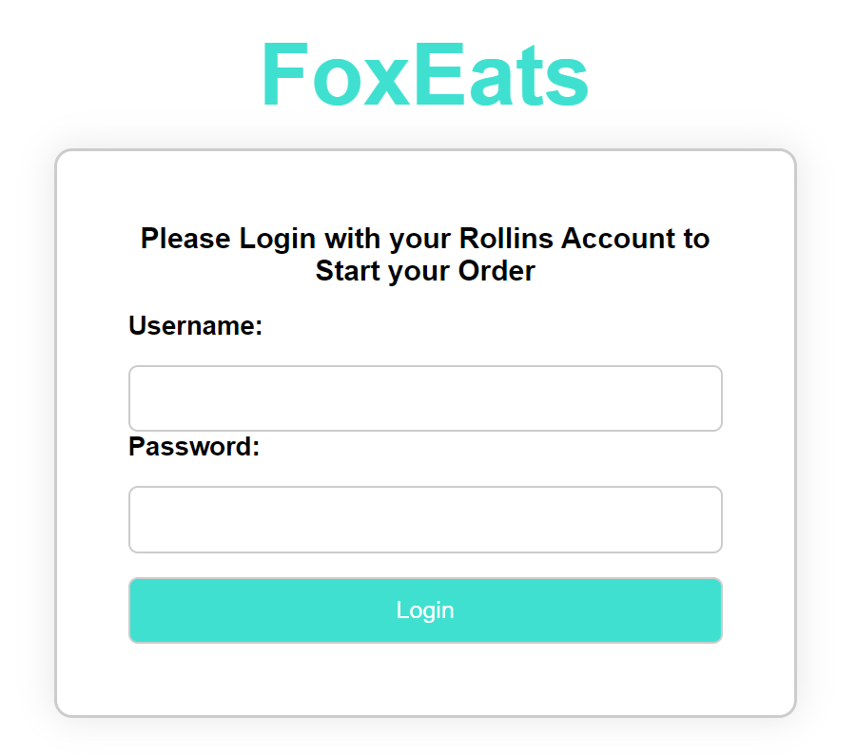

For the image below, this is the Home screen and this is where all 5 restaurants available are shown and the users can select which they would like to place an order from, but if they select one which they do not want they can always return to this home screen to select the correct one.

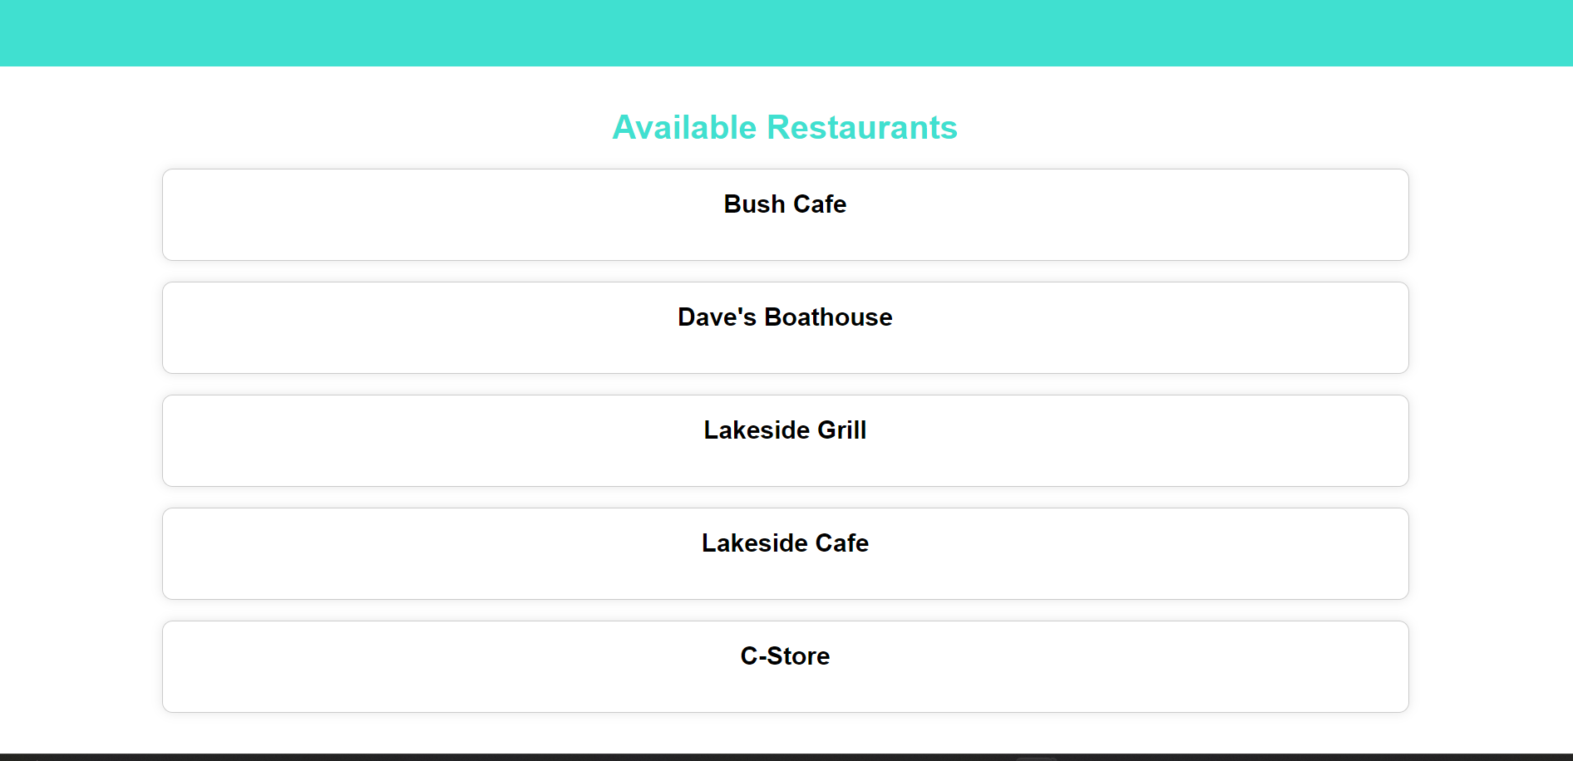

For the image below, this is the screenshot of 1 of our 5 restaurants, from this screen, you are able to select from the two menu options that also have a brief description of what it is and by clicking the Order button it will proceed to the Confirm Order Screen or by clicking the Back button to go back to the homepage.

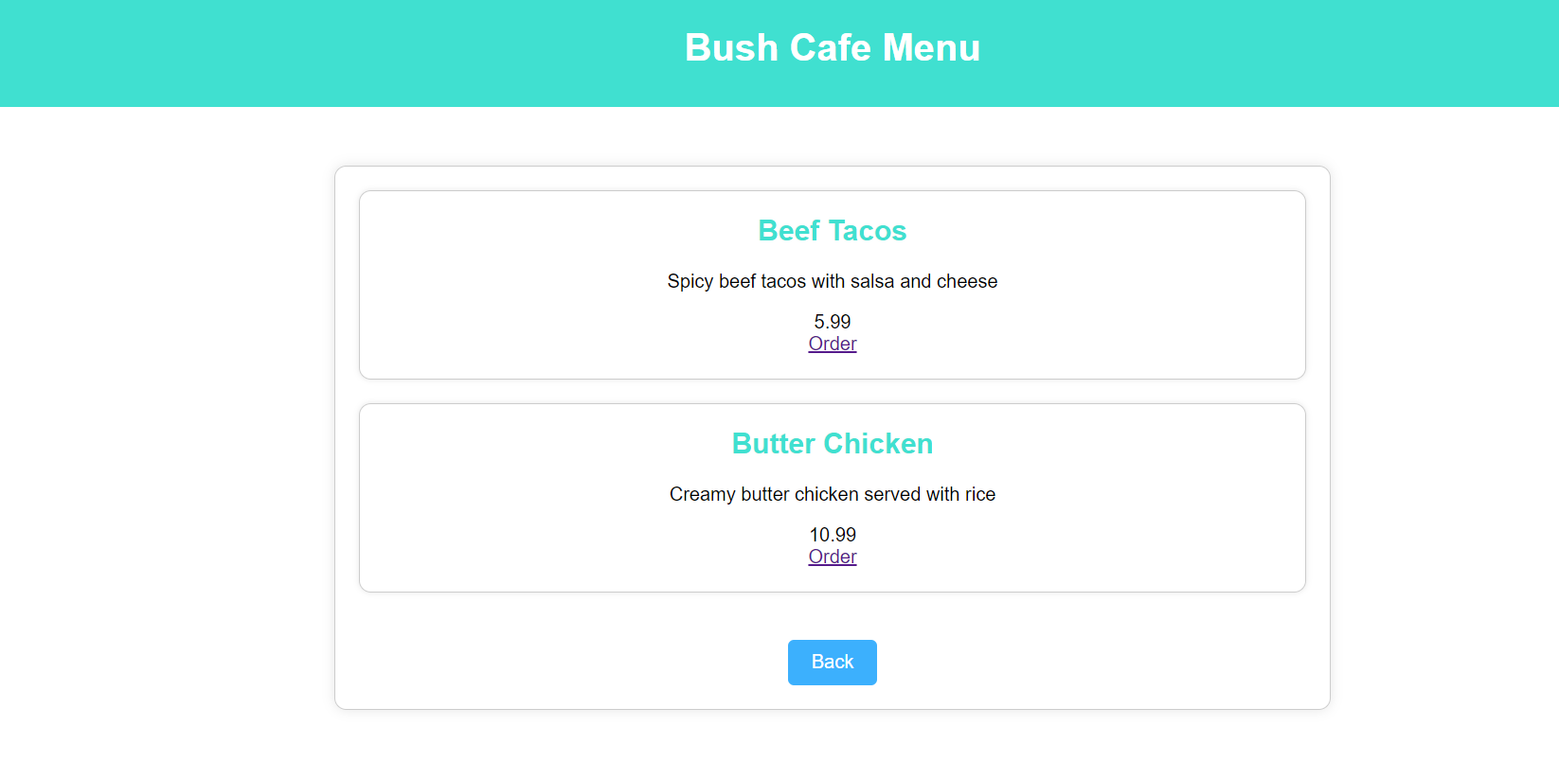

For the image below, this is a screenshot of our 2 of 5 restaurants, from this screen, you are able to select from the two menu options that also have a brief description of what it is and by clicking the Order button it will proceed to the Confirm Order Screen or by clicking the Back button to go back to the homepage.

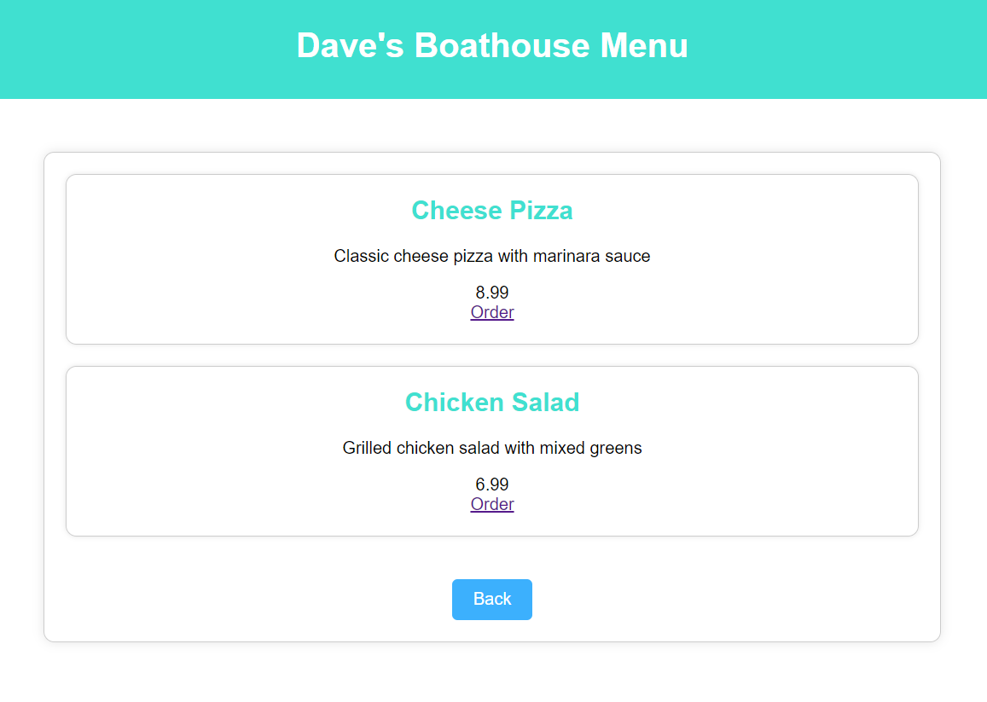

For the image below, this is a screenshot of our 3 of 5 restaurants, from this screen, you are able to select from the two menu options that also have a brief description of what it is and by clicking the Order button it will proceed to the Confirm Order Screen or by clicking the Back button to go back to the homepage.

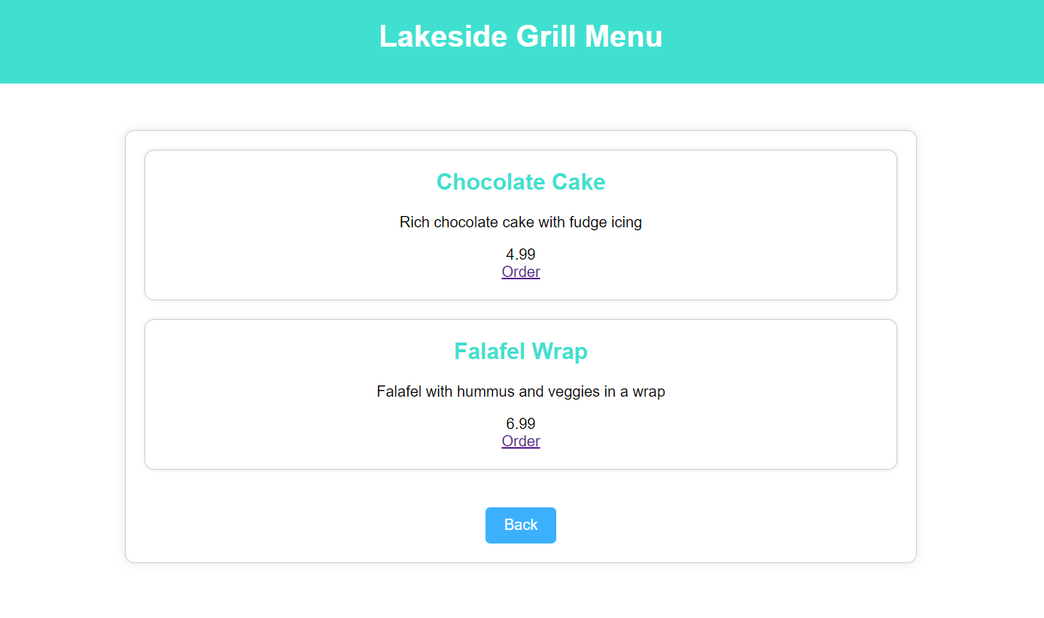

For the image below, this is a screenshot of our 4 of 5 restaurants, from this screen, you are able to select from the two menu options that also have a brief description of what it is and by clicking the Order button it will proceed to the Confirm Order Screen or by clicking the Back button to go back to the homepage.

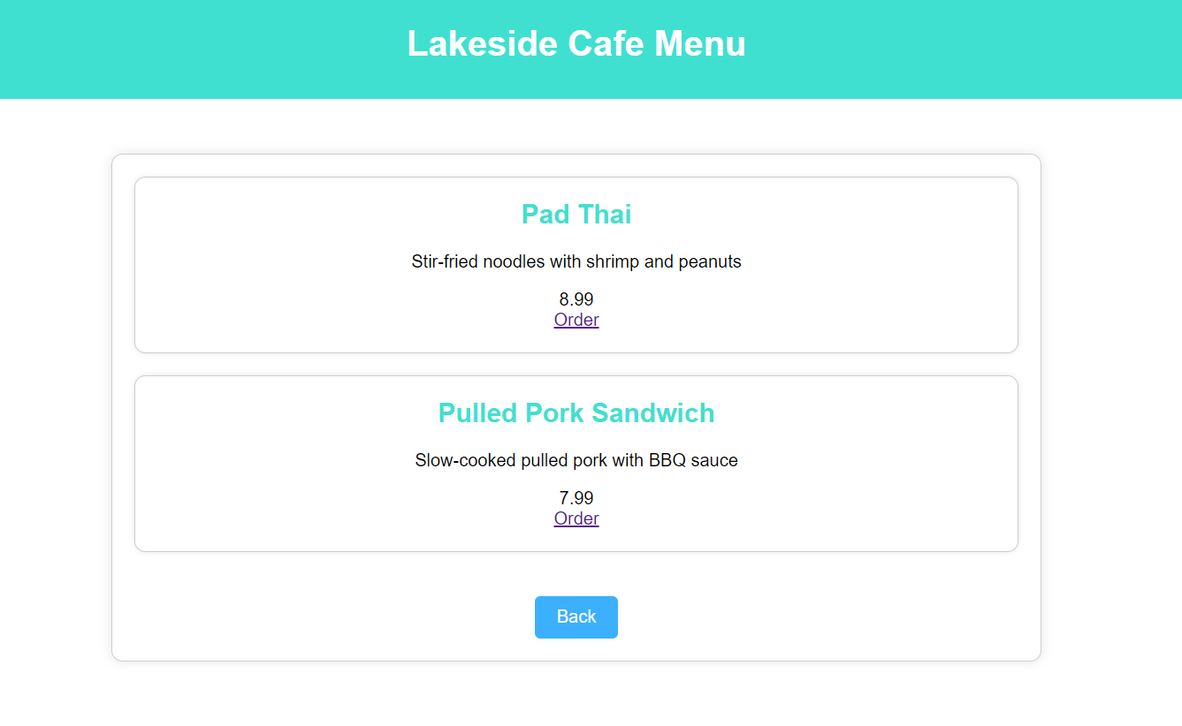

For the image below, this is a screenshot of our 5 of 5 restaurants, from this screen, you are able to select from the two menu options that also have a brief description of what it is and by clicking the Order button it will proceed to the Confirm Order Screen or by clicking the Back button to go back to the homepage.

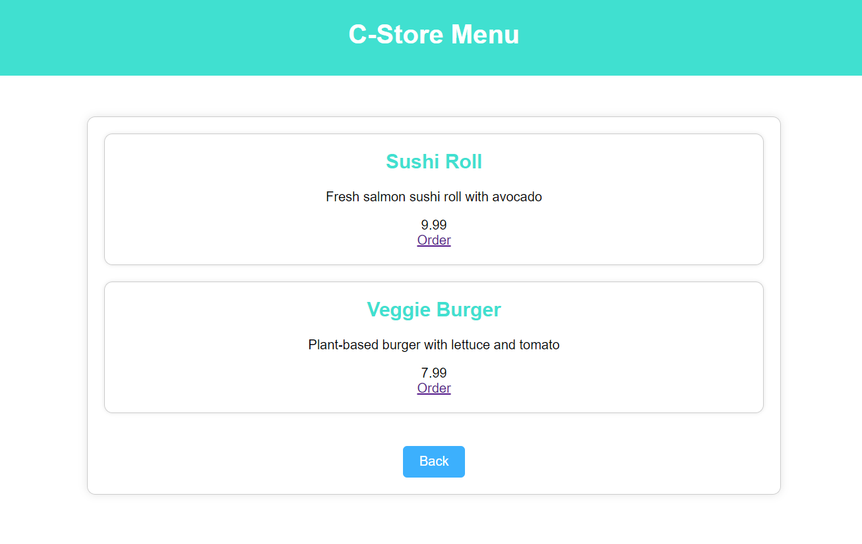

For the image below, this is a screenshot of Confirmation Screen, it shows the items that are selected, the total amount, it has the option to remove the items that are selected individually, it has the option to add more which brings you back to the home page to choose from any of the restaurants of choice and then select the meal you want to add, there is a button to delete order which deletes everything, and the Pay button which goes to the payment screen.

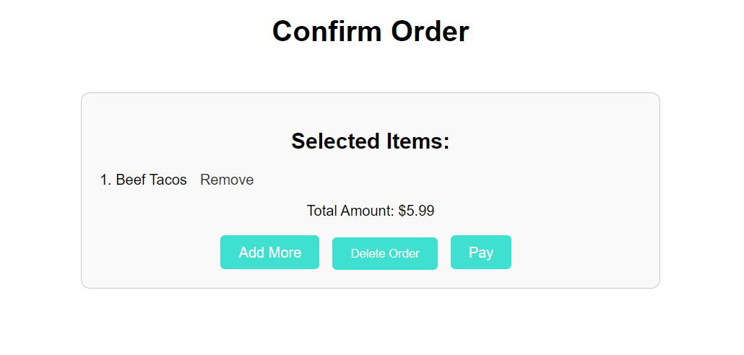

For the image below, it is a screenshot of our Payment Screen where you have three options, the first one is going back to the Confirmation Page, the second one is Paying with R-Card and the third one is Paying with Credit Card. for the R-Card and Credit Card information these are data that we have in our SQL Database that will be checked to ensure it matches before it proceeds, if not it will prompt the user to re-enter the data.

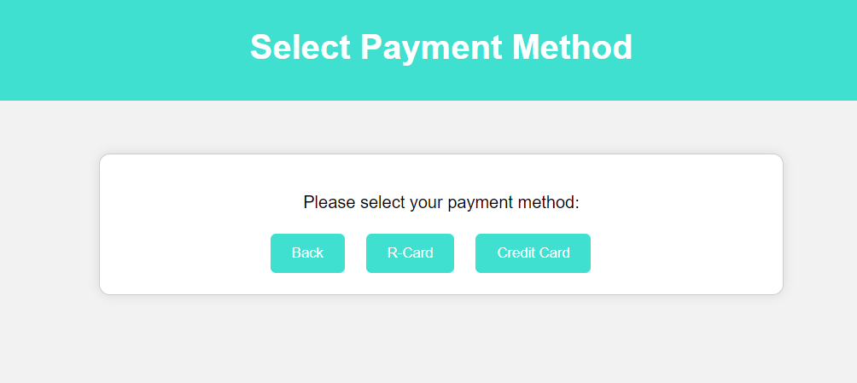

For the image below, it is a screenshot that shows our Order Received Screen, meaning that the information added in the previous screen was correct, and the user’s order is saved for the restaurants to start making the food. The Home button will return the user back to the Home Screen.

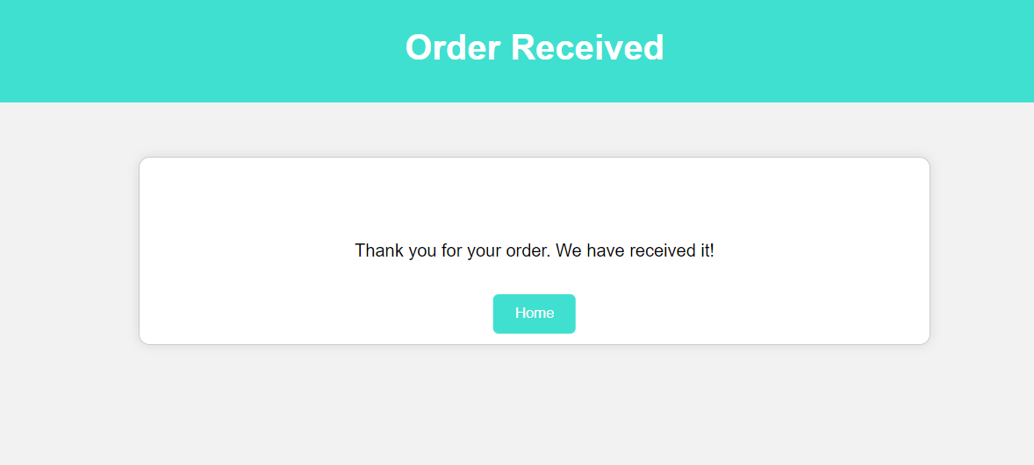

**Discussion and Conclusion:**

To conclude our project, we developed FoxEats, a website designed to be similar to apps like UberEats and Grubhub, but in a more local setting for students to use and put orders in. Throughout the project, we had to learn a lot about the intricacies of HTML, as well as solving connection issues with the database and our website. We tried several different approaches to solve this problem, until we decided to create a separate PHP connection file that connects throughout our website without having that section being copied in every webpage, it is simply included. Some of our biggest accomplishments were forming that connection, as well as creating a way to prevent SQL injection by limiting the user’s input options. We had a lot of help online by looking up our obstacles through the internet and found others experiencing the same issues as us through various forum websites for coders. We hope that this project’s lessons carry over to other projects that we have planned ahead in our lives.

**References:**

Fitzgerald, A. (2024, April 3). How to make an HTML text box [examples]. HubSpot Blog. <https://blog.hubspot.com/website/html-text-box>

How to - login form. How To Create a Login Form. (n.d.). <https://www.w3schools.com/howto/howto_css_login_form.asp>

HTML in 100 seconds. YouTube. (2021, December 3). <https://youtu.be/ok-plXXHlWw?si=TIdXcWk945_cDnW7>

How to validate html textbox not to allow special characters and space? (n.d.). Stack Overflow. <https://stackoverflow.com/questions/24774367/how-to-validate-html-textbox-not-to-allow-special-characters-and-space>

Using HTML container tags explained with examples. codedamn news. (2022, December 4). <https://codedamn.com/news/frontend/using-html-container-tags-explained-with-examples>

‌

‌

‌

‌